**PHASE -1**

**Final Project Details**

Date: 06/03/2022

**Project Name:** Virtual Key for Your Repositories

**Project Developed Language:** Java

**Software Used:** Eclipse IDE for Developers 2021-12

**Version Control & Remote Accessing:** GitHub

**Developer Details**

**Name:** Rajagopal Sai Krishna

**Employee Id:** 2499086

**GITHUB Repository Link:**

**Project Details:**

This project is developed to create a file system which is capable of listing the files in Directory and Also perform so functions like Creating a new file in the directory, Deleting Files in the directory. It also allows the user to search all the files with a particular name in the directory.

**Sprint Details:**

**Sprint 1:**

In the 1st sprint, A basic Structure of the application was developed, With the simple capability of listing the files present in the directory.

The application has a three-tier structure, Main Menu, Sub Menu and Data Access Layer.

1. Main Menu is responsible for taking the inputs from the user and take the input from the user.
2. Sub Menu is responsible for giving more options to user and take the input from the user.
3. The data access layer processes this user input and performs the operations as per the user input.

This basic structure was created using concepts like Multiple Classes, Implementing Interfaces. Also, the logic to list the file present int root directory was developed.

**Sprint 2:**

In the 2nd Sprint, Creation of a sub menu. Which contains Adding the Features like Creating File, Deleting File, Searching a file in the Directory.

This sprint also included the Testing of the project with different User Test Cases to make sure the project is working without any errors or exceptions. And pushing the code into GitHub using Git.

**Program Explanation and Flow Chart:**

|  |  |  |
| --- | --- | --- |
| **Class** | **Method** | **Description** |
| FileOperations |  | Perform various operations like list all files in ascending order, create new file, delete file and search file using data structure concepts. |
|  | Void list_All_Files() | This Method in directory in ascending order and display the file present in directory of given path. |
|  | Void Create_New_File(String Filename) | This method gives user to create new file in the directory and gives the output as a file created successfully else gives output as a file already exists in the given directory. |
|  | Void Delete_File(String Filename) | This method take user input as a String and deleting the file in directory which match with user input with files present in directory and gives the output to user. |
|  | void Search_File(String filename) | This method take user input as a String and search the file in directory which match with user input with files present in directory and gives the output to user. |
| MainMenu |  | This class provides various options to user to choose any options by user convenience. |
| LockedMeDir |  | Main class and also display welcome message with developer details. |

**Flow Chart:**

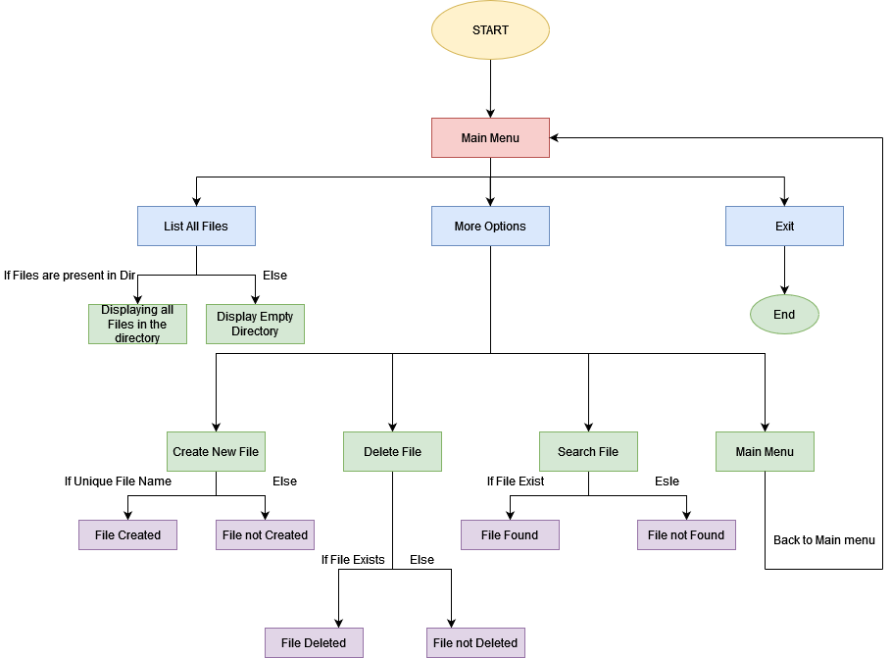

**Core Concepts Used in Project:**

1. Classes
2. Constructors
3. Collections
4. File Class
5. For Loop, Do While
6. Switch Case, If-Else
7. Sort Algorithm
8. Search Algorithm

**Conclusion:**

This Project has a huge scope of improvement. One can easily add the functionality for navigating within files, and adding, deleting files within a folder of the directory. Also, a functionality to write within the text files can be added. The project is that once fully developed it can act as a complete file management system and can be used by individuals to safe keep data in serialized form. That is an additional feature that needs to be implemented there by one can keep his data in a secure format.